# 

# **Demand No267 - API SEAPIM (Apigee) Requirements – Case Entities API V1.1**

{

}

}

Contents

**API** 2

Project Background 2

Sequence Diagram 3

SEAPIM Requirements 4

Statistics Collection 5

Exception Requests/Waivers 6

Approvals: 6

**Authors: APIFIRST Team**

**Digital Architecture**

|  |  |  |  |
| --- | --- | --- | --- |
| **Version & Date** | **Created/Changed by** | **Change details** | **Reviewed/Approved By** |
| **0.1/ July 08, 2020** | **Camille WILLEME** | **Pre -ADR #1** |  |
| **0.2/August 3rd, 2020** | **Camille WILLEME** | **Post-ADR #1** |  |
|  |  |  |  |
|  |  |  |  |

# **Case Entities**

AViD API Design URL:

<https://se-avid.stoplight.io/studio/gh1/AViD-API-Design/No47---RPA-Case-APIs>

--> branch version/1.3

Underlying Backend API including Technical Specification and payload sample:

* + **Post /return-requests:**

This API method provides the ability to create in bFO a return request record related to a case.

This API requires the case-number or case-id to which the Return request will be linked.

If none of the query parameter is populated or both of them are populated the API returns an error.

Input body example:

{

"contactId": "003A000000xz2EKIAY",

"productCondition": "Defective",

"customerResolution": "RFC",

"accountStreet": "257, Lotissement LINA - Sidi Maârouf",

"additionalComments": "Product was received and signed for by C Cobell on 30 August. The serial number for this meter is MJ-1202A712-03. Model number is M7650B1C0C5E0A0E.",

"seOrderReference": "1020324458",

"customerRepairPONumber": "PO-00002000"

}

Output body example:

{

"returnRequestId": "5045F0000099CpI"

}

Backend URLs:

bFO is the backend.

|  |  |  |  |  |
| --- | --- | --- | --- | --- |
| **ENV** | **API Operation path (Apigee)** | **Backend Service-Host** | **Backend Service Base Path** | **Backed Service Operation Path** |
| DEV | POST: /v1/customer-support/case-entity  /return-requests | <https://se--sitbfo20.cs62.my.salesforce.com/> | /services/apexrest/customer-support/case-entity | /return-requests |
| QA | POST: /v1/customer-support/case-entity  /return-requests | <https://se--uatbfo19.my.salesforce.com/> | /services/apexrest/customer-support/case-entity | /return-requests |
| PRE-PROD | POST: /v1/customer-support/case-entity  /return-requests | <https://se--preprod19.cs17.my.salesforce.com/> | /services/apexrest/customer-support/case-entity | /return-requests |
| PROD | POST: /v1/customer-support/case-entity  /return-requests | <https://se.my.salesforce.com/> | /services/apexrest/customer-support/case-entity | /return-requests |

Backend Security Model:

**Backend Security Credentials:**

Provide the process and credentials to generate token for all environment based the security model.

OAUTH2

The API requires **X-BFO-Authorization** for users

* **Comments (unchanged from #170)**
  + **Get Comment:**

This API methods allow the consumer to retrieve the list of comments related to a specific case record in the backend system. The API accepts as input query parameter the case-id or the case-number of the related case record (if none of those 2 query parameters is populated or both of them are populated the API returns an error), as well as is-public (optional)

Output body example:

[

   {

      "commentId":"00a1200000BUrjTAAT",  
      "commentBody":"this is a test comment 1",  
      "createdBy":"005A0000004KCru",  
      "sendNotification": true,  
      "isPublic": false

},

{

"commentId":"00a1200000AQrjTAAT",  
     "commentBody":"this is a test comment 2",  
      "createdBy":"005A0000004KCru",   
      "sendNotification": false,  
      "isPublic": false

}

]

* + **Create Comment:**

This API provides the ability to create in the backend system a comment record related to a case. This API requires the case-number or case-id to which the comment will be linked as query parameters of the API

Input body example:

{

   "commentBody":"this is a test comment",  
   "createdBy":"005A0000004KCru",  
   "sendNotification": true,  
   "isPublic": false

}

The API returns the Id of the created comment:

{

"commentId": "00a1200000BUrjTAAT"

}

|  |  |  |  |  |
| --- | --- | --- | --- | --- |
| **ENV** | **API Operation path (Apigee)** | **Backend Service-Host** | **Backend Service Base Path** | **Backed Service Operation Path** |
| DEV | GET | POST:/v1/customer-support/case-entity/comments | <https://se--sitbfo20.cs62.my.salesforce.com/> | /services/apexrest/customer-support/case | /comments |
| QA | GET | POST:/v1/customer-support/case-entity/comments | <https://se--uatbfo19.my.salesforce.com/> | /services/apexrest/customer-support/case | /comments |
| PRE-PROD | GET | POST:/v1/customer-support/case-entity/comments | <https://se--preprod19.cs17.my.salesforce.com/> | /services/apexrest/customer-support/case | /comments |
| PROD | GET | POST:/v1/customer-support/case-entity/comments | <https://se.my.salesforce.com/> | /services/apexrest/customer-support/case | /comments |

* **Case Lines (unchanged):**

retrieve the case lines related to the case identified by the given caseId or caseNumber.

* + Input parameter: caseId or caseNumber
  + Output body example:

{   
   **"caseLines"**:[   
      {   
         **"installedProduct"**:"a1a4F000001Lb6cQAC"  
      },  
      {   
         **"serialNumber"**:"12345678",  
         **"quantity"**:1.0000,  
         **"installedProduct"**:"a1a4F000001Lb6hQAC"  
      },  
      {   
         **"installedProduct"**:"a1a4F000001Lb6XQAS"  
      }  
   ]  
}

* **External References (unchanged):**
  + External references read:

retrieve the external references related to the case identified by the given caseId or caseNumber.

Output body example :

{   
   **"externalReferences"**:[   
      {   
         **"type"**:"Alarm",  
         **"systemReference"**:"8fd06aee-3b09-45a9-bf13-932417ae81b8",  
         **"clientReference"**:"A-6252"  
      },  
      {   
         **"type"**:"Alarm",  
         **"systemReference"**:"8fd06aee-3b09-45a9-bf13-932417ae81b8",  
         **"clientReference"**:"A-6252"  
      },  
      {   
         **"type"**:"Alarm",  
         **"systemReference"**:"8fd06aee-3b09-45a9-bf13-932417ae81b8",  
         **"clientReference"**:"A-6252"  
      }  
   ]  
}

* + External Reference creation:

create an external reference record in bFO that is related to a case identified by its caseId or caseNumber

Input body example:

{   
   **"type"**:"Alarm",  
   **"systemReference"**:"8fd06aee-3b09-45a9-bf13-932417ae81b8",  
   **"clientReference"**:"A-6252"  
}

* **Literature Request (unchanged):**

retreive the detailed list of literature requests records related to a case in bFO, by providing as parameter the caseId or caseNumber.

* + Input parameter: caseId or caseNumber
  + Output body example:

{   
   **"literatureRequests"**:[   
      {   
         **"quantity"**:1,  
         **"contact"**:{   
            **"zipCode"**:"302019",  
            **"street"**:"60 Feet Road Vardhman Nagar Gajsinghpura",  
            **"state"**:"Rajasthan",  
            **"name"**:"Test Contact",  
            **"country"**:"India",  
            **"city"**:"Jaipur"  
         },  
         **"commercialReference"**:"E44331NA6M0D18M",  
         **"account"**:{   
            **"zipCode"**:"302019",  
            **"street"**:"60 Feet Road Vardhman Nagar Gajsinghpura",  
            **"state"**:"Rajasthan",  
            **"name"**:"Test",  
            **"leadingBusiness"**:"PP",  
            **"country"**:"India",  
            **"classificationLevel1"**:"LC",  
            **"city"**:"Jaipur"  
         }  
      }  
   ]  
}

* **Emails (unchanged):**

This API methods allow to send an email related to a case, it accepts as input body the details about the email to send (sender, recipients, subject, content, email template (if any), existing case attachment ...)

Input body example:

{

   "senderDisplayName":"CCC Support",  
   "recipients":[

      "ibtissam.elaousli@edifixio.com",  
      "ibtissam.elaousli@non.se.com"

],  
   "content":"this is the email content body",  
   "subject":"test API Email",  
   "attachmentIds":[

      "00P4F000004Xk4P",  
      "00P4F000004Xk4U"]

}

An http response code 200 indicates that the request is successful

Backend URLs:

bFO is the backend.

|  |  |  |  |
| --- | --- | --- | --- |
| **ENV** | **HOST** | **Base Path** | **RESOURCE - PATH** |
| DEV | <https://se--sitbfo19.cs17.my.salesforce.com/> | /services/apexrest/customer-support/cases | **Case Lines**: /case-lines **Literature Request**: /literature-requests  **External References**: /external-references  **Emails**: /emails |
| QA | <https://se--uatbfo19.my.salesforce.com/> | /services/apexrest/customer-support/cases | **Case Lines**: /case-lines **Literature Request**: /literature-requests  **External References**: /external-references  **Emails**: /emails |
| PRE-PROD | <https://se--preprod19.cs17.my.salesforce.com/> | /services/apexrest/customer-support/cases | **Case Lines**: /case-lines **Literature Request**: /literature-requests  **External References**: /external-references  **Emails**: /emails |
| PROD | <https://se.my.salesforce.com/> | /services/apexrest/customer-support/cases | **Case Lines**: /case-lines **Literature Request**: /literature-requests  **External References**: /external-references  **Emails**: /emails |

Backend Error Structure and Http Status code:

1. Http status Code:
   1. 200: Success
   2. 400: Bad Request
   3. 403: Forbidden
   4. 404: Not Found
   5. 500: Internal Server Error
2. Error Structure :
   1. errorCode: the unique error code
   2. message: the explanation of the occurred error.

Example:

[{   
   **"errorCode"**:"NOT_FOUND",  
   **"message"**:"The provided resource is not found [application]:'a3z4F000000TJh'"  
}]

For the mapping with Apigee standard error structure:

* errorCode to **code**
* message to **userMessage**
* If Http status code is **500** (technical issue) map: message to **developerMessage**

Consumer App: Blue Prism

## 

## Project Background

## API to facilitate management of return-request RMA (Non-ITD) process via internal Schneider applications

## Sequence Diagram

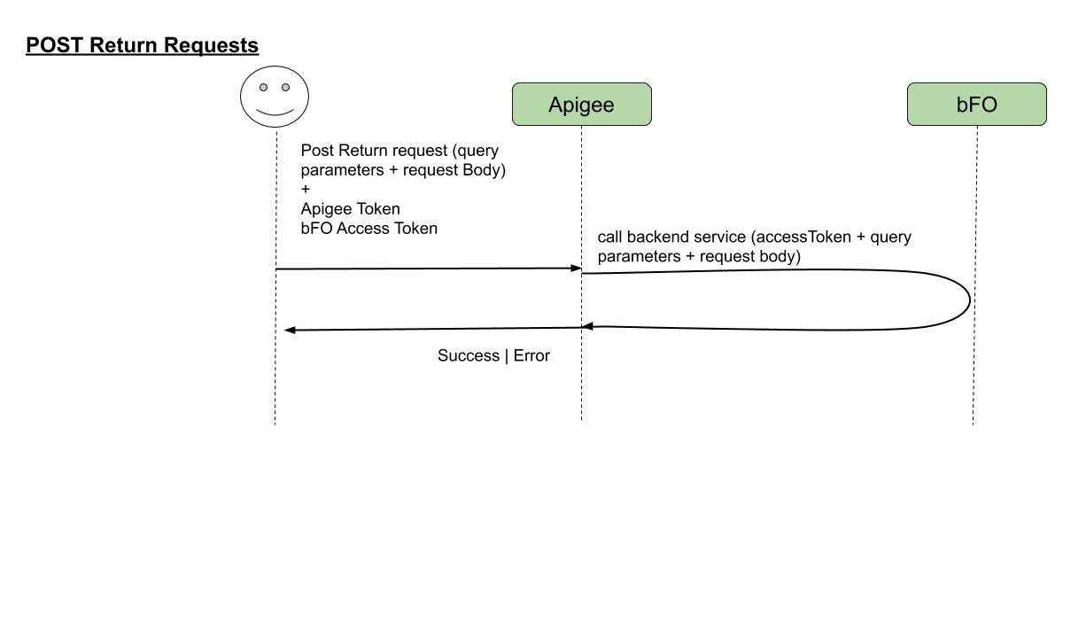

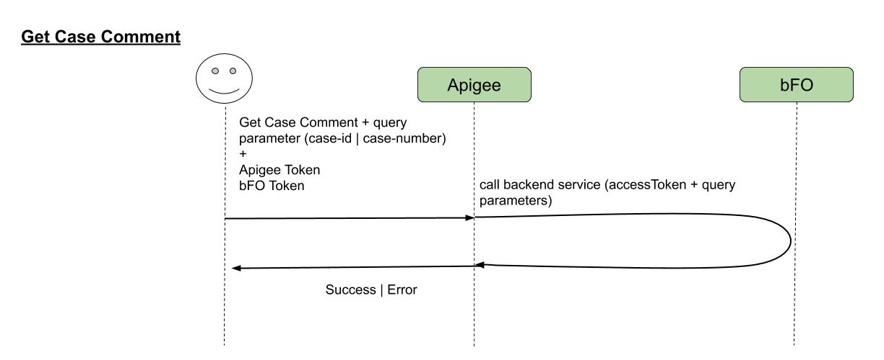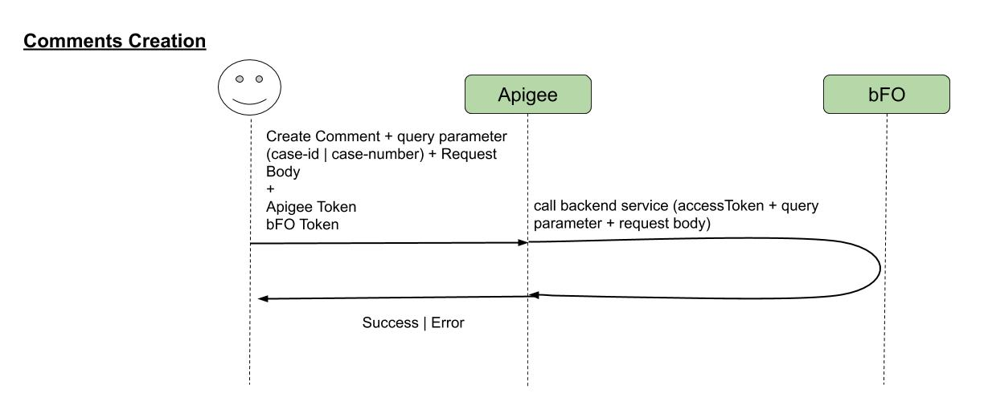

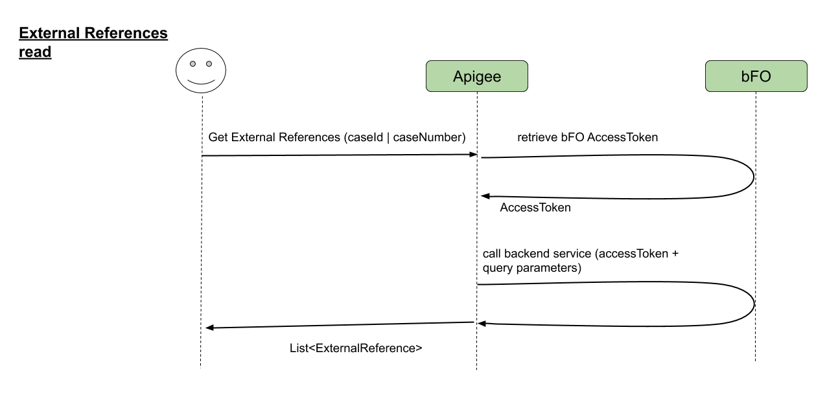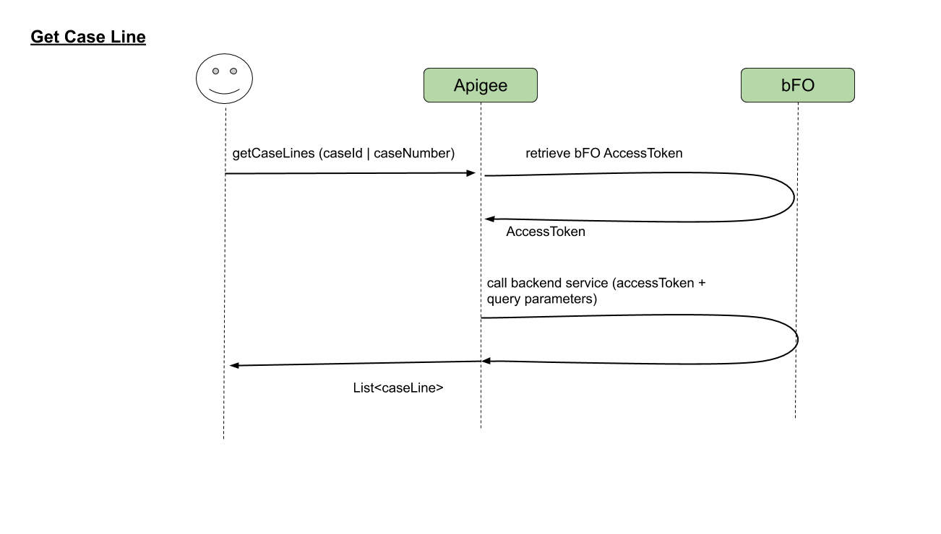

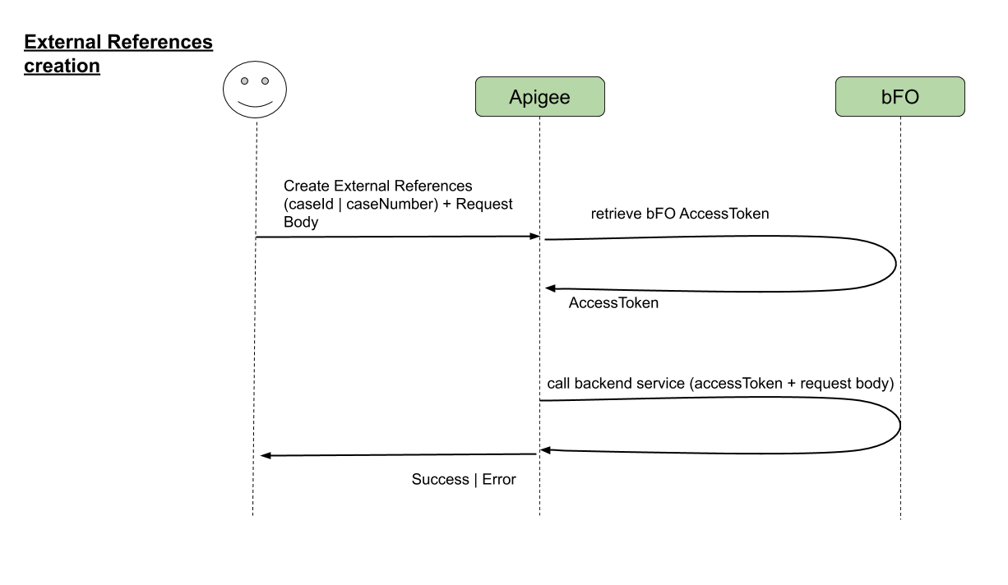 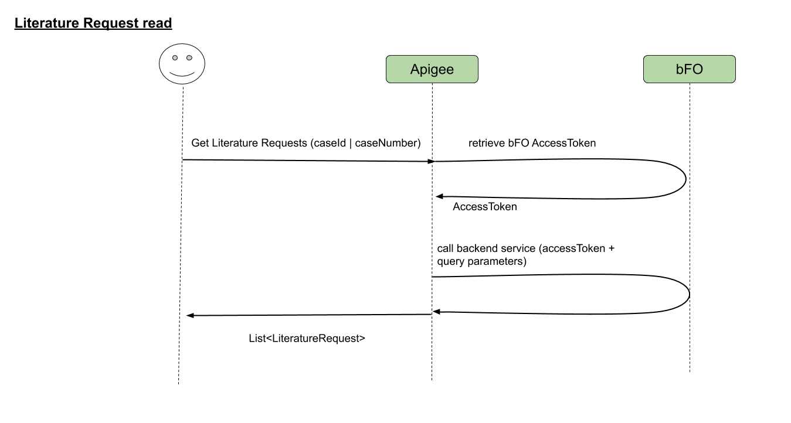

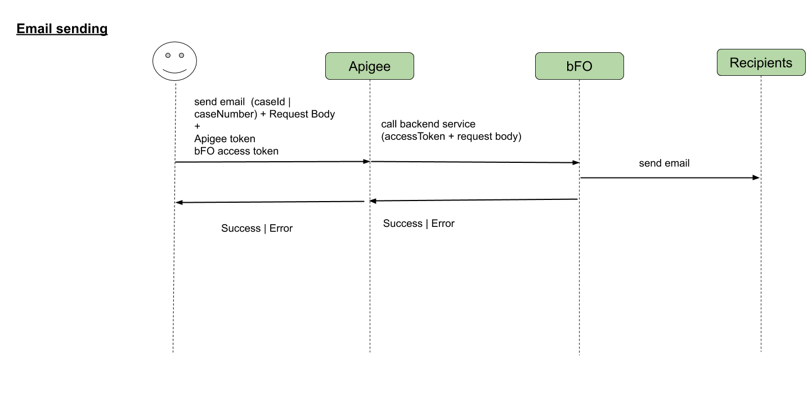

## SEAPIM Requirements

|  |  |  |  |  |
| --- | --- | --- | --- | --- |
| **Security** | Yes/No | Parameter | Value | |
| Apigee Token Generation | Yes | Grant Type | Client Credentials | |
| Apigee Token Verification | Yes |  | After SEAPIM token is validated, remove the Authorization header. | |
| Apigee Token Caching | Yes | Expiry | 1 hour | |
| Backend Server Apikey Caching | Yes |  |  | |
| JSON & XML Threat Protection | Yes | Max Array Length |  | |
| Max Depth |
| Logging | Yes, but limited |  |  | |
| Mask payload fields e.g. personal data | No |  | No field level masking relevant as the request/response bodies will be suppressed. | |
| Back end Security | Yes |  | Backend access token should be passed | |
| **Traffic Management** | Yes/No | Parameter | Value | |
| Spike Arrest | Yes | Rate | Default: 30 calls/sec. | |
| Developer Quota (External Consumer) | No | Rate | n/a | |
| Developer Quota (Internal Consumer) | Yes | Rate | 10000 calls/day per consumer | |
| Concurrency Limit | No | Rate | n/a | |
| Get Response Caching | No | Expiry |  | |
| **Mediation** | Yes/No | Mapping Rule | | |
| Forward Client App token to Backend | Yes | Backend access token should be passed | | |
| Request is pass through to the backend | Yes |  | | |
| Response is pass though to the client from backend | Yes |  | | |
| Request mapping logic (header, verb, path, query param, payload fields) | Yes | Allow all elements to pass through unchanged. Please provide mapping for request and response if applicable . | | |
| Response mapping logic (header, path, payload attributes) | Yes | Allow all elements to pass through unchanged | | |
| Backend server routing logic | No | n/a | | |
| HTTP Status code mapping logic | No |  | | |
| Data Validation | No | Backend will be doing all data validation | | |
| Standard Error Response mapping logic | Yes | See Backend Error Structure and Http Status code section | | |
| **Reporting/Monitoring** | **Yes/No** | **Mapping Rule** | | |
| Custom Statistics Collection | Yes | Analytics of interest.  These reports can be satisfied by Apigee out-of-the-box statistics. No code is required.   * Call count by consumer app, sub-categorized by country * Call count by HTTP status code * Average and maximum response times by consumer app, shown as a time range distribution | | |
| **Network connectivity** | **Yes/No** |  | | |
| Backend regional server routing | No |  | | |
| Continuous streaming mode | No |  | | |
| Call timeout | Yes | Max timeout | | Default: 30s |
| Backend connection time out | Yes |  | |  |
| Backend IO time out | Yes |  | |  |
| SSL – 2-WAY / 1-WAY | 1 -WAY | Since client authentication is not required as the API is only for internal applications | | |
| Accessibility – Public | No |  | |  |
| RP – Configuration (To make service publicly accessible) | No | Provide all the environment, region server IP ,Port and Resource Path | |  |

|  |  |  |
| --- | --- | --- |
| **Backend Service Supported Content** | **YES/NO** | Comments |
| Backend produce/consume both - XML/JSON | NO |  |
| Backend produce/consume only - JSON | YES |  |
| Backend produce/consume only - XML | NO |  |

|  |  |  |
| --- | --- | --- |
| **Pay Load Size** | Maximum Limit in MB | Comments |
| Response |  |  |
| Request |  |  |

|  |  |  |
| --- | --- | --- |
| **Support Contact details** | Name | Email |
| Backend support group | Camille WILLEME | camille.willeme@non.se.com |
| Product Owner | Pooja Suresh THAYIL | Pooja.Suresh@se.com |

## Approvals: